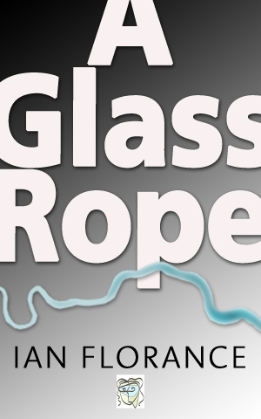

Now available on Amazon as a Kindle e-book, Kobo, an i-book for Apple devices and a Barnes and Noble Nook.

978 0 956 7577 2 2 c552 pages £3.99

'It's a fantastic achievement. There is so much packed in there: so many ideas, observations and conjectures on issues of class, technology, emotional development, family, education, literature, memory, psychology, dystopian visions, London, the Thames – and so on! And at the heart of it is the timeless, Everyman story of a man finding his way in worlds both familiar and unfamiliar’ : Lucy Ridout.
A GLASS ROPE
Adam Mahfouz is mugged and his life starts to fall apart. He is a tutor on the Cull, a global educational programme aimed at reducing social inequality and ethnic tension in the 2060s. He was brought up in a poor, ethnically mixed background and is proud of his status as a ‘scholarship boy’ and what he’s achieved in his working life. His mugger is a former pupil, Leila, who gradually invades his life. Adam begins to record his past obsessively. He grows fascinated by memories of his teenage years when he was seduced by a group of rich, self-indulgent kids, including the charismatic, unstable Nathan. This period led to five deaths, including Nathan’s, and the disappearance of Adam’s sister. He also records what’s happening to him as he writes. He loses his home and job (and nearly his life), and he and Leila set out to walk through and under London to beg help from Nathan’s now aged billionaire father. Together they explore a London divided by extremes of wealth and by ethnicity, culture and religion; which mixes 400 year old buildings and subterranean archaeological sites with futuristic technology. The journey ends in a Gravesend tomb where two more people die. In the same place, Adam remeets his sister after 30 years of separation. They live together in Kings Cross and, as Adam completes writing his memories and gets involved with an ambiguous gang of low-lifes, he finally discovers the truth about his life, his job and his past….
A Glass Rope is about London and the Thames – the ‘glass rope’ of the title – and draws on stories the author’s father and grandfather told him about their lives in Bermondsey.
_____________________________________________________________
IAN FLORANCE
Ian Florance lives in Henley-on-Thames. He took degrees in English and Art History at Reading and Leeds Universities. He now works in applied business psychology across Europe. Ian set out to write a three volume, 1500 page poem, Messengers, ( it seemed like a good idea at the time) and founded OnlyConnect Publishing to publish it as well as Gemini Four, worked on with a group of friends that included the then Archbishop of Canterbury Rowan Williams. Ian has written librettos for the musical Heloise which was premiered at Southwark Cathedral and a modern Requiem He reads at literary and arts festivals and has organised one stream of the Henley Literary Festival. He's written for a number of national newspapers and journals and has appeared on Radio 5 Live and Capital Radio. He was visiting tutor to graphic design students and also taught writing at Central St Martins College of Art and Design.

